feb
WSTA Science Cafe
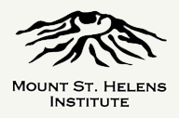
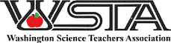

Next Meeting Tuesday January 23rd
Mill Creek Pub 5 pm-6:30
WACAS Test and Item Specs
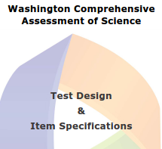
Asking Questions, Investigating, Analyzing Data, Using Mathematics, Using Models, Arguing with Evidence, Constructing Explanations and Communicating information about the Washington Comprehensive Assessment of Science.
Webinars from OSPI on using the training test and the test and item specifications will be on January 10th (training test) and January 24th (Test and Items Specifications)
Questions? Mark Watrin watrin.mark@battlegroundps.org WSTA Representative SW Washington region 8
Carol Sandison Carol.Sandison@vansd.org WSTA clock hour registrar
Directions: From hwy 503 turn East on Eaton Blvd (199th st) then left at 9th and into the parking area close to the BG Cinema.
