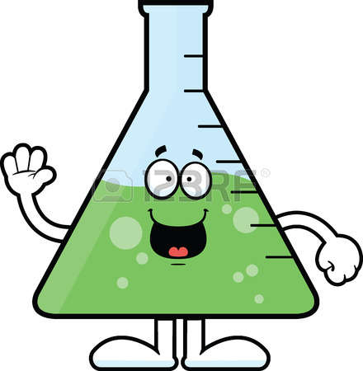

6:30 Socializing – 7:00 PresentatION

March 13 – Nisqually, Leading the Way in Conservation Through Strong Community Action.

# April 10 – Washington’s Humble Bumbles

May 8 – Wolves in the Classroom: An Overview of Wolf Haven and Education

June 12 – Mount St. Helens: The May 18, 1980 Eruption and Beyond

For more information and registration please visit WSTA.wildapricot.org

Spring Science Talks Hosted by

***WSTA(Washington Science Teachers Association)***

@ **Three Magnets Brewing** in Olympia

OLY

SCIENCE

BREWS

### [Day]

[Date]